**CHORMA CONNECT CEILING FANS:**

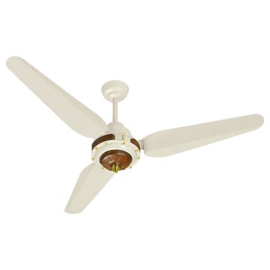

**Price: 10,295.00**

Chroma Connect Fans represent the latest innovation in smart cooling technology. These sleek and modern fans boast advanced features such as Wi-Fi connectivity, voice control through Alexa and Google Assistant, and seamless integration with smart home systems. The Chroma Connect Fans app allows users to remotely control and schedule fan operations, monitor energy consumption, and receive notifications. With their energy-efficient design, whisper-quiet operation, and stylish designs, Chroma Connect Fans provide unparalleled convenience, comfort, and style. Whether for residential or commercial spaces, Chroma Connect Fans offer a perfect blend of innovation, functionality, and sustainability, making them a superior choice for those seeking a smart and connected cooling solution.

* **Key features of chorma connect ceiling fans include:**
* **Smart Connectivity:** Control via mobile app or voice assistants like Alexa and Google Assistant.
* **Inverter Motor:** Energy-efficient and quiet operation.
* **Multiple Speed Settings:** Adjustable airflow for personalized comfort.
* **Remote Control:** Easy to adjust settings from a distance.
* **Modern Design:** Stylish and contemporary look for any room.
* **Reversible Function:** For improved air circulation in both summer and winter.
* **Energy Efficient:** Reduces power consumption and lowers electricity costs.